**Azure Virtual Network and Virtual Machines**

**Case Study : Deploy an application in the VM and access using the public IP**

Below are the screenshots of the steps followed.

Screenshot 1:

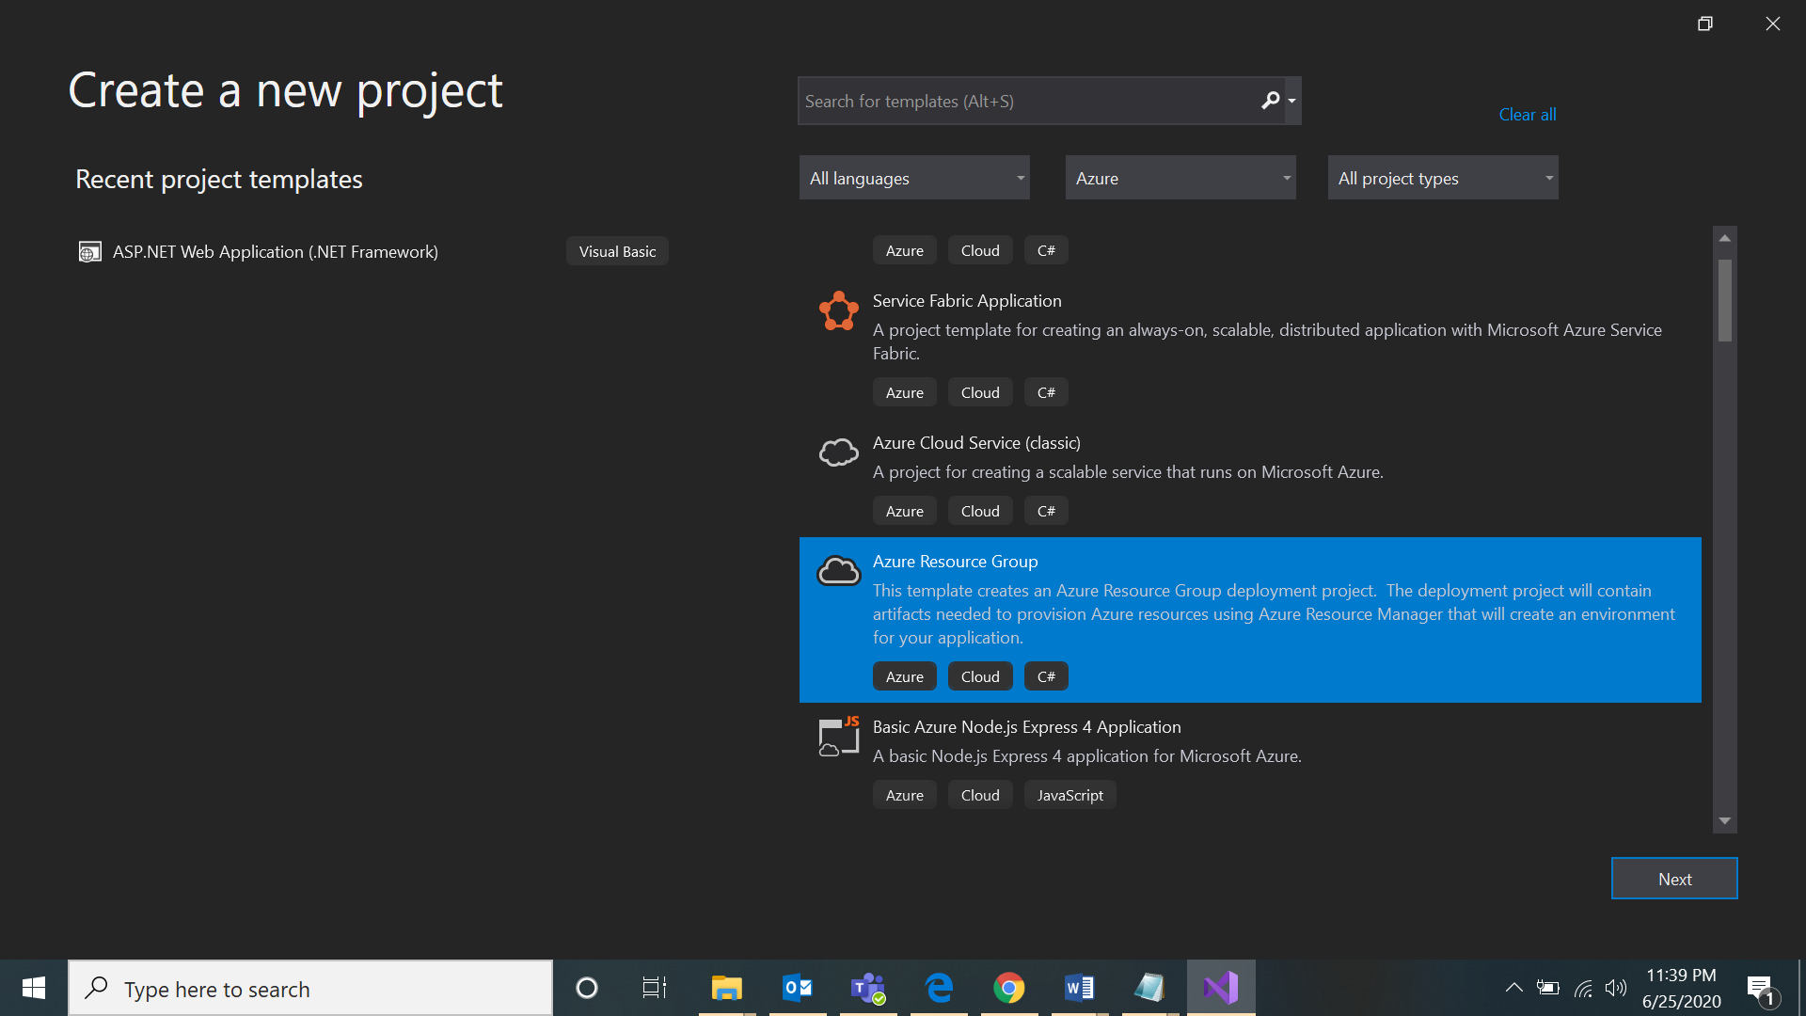

Screenshot 2:

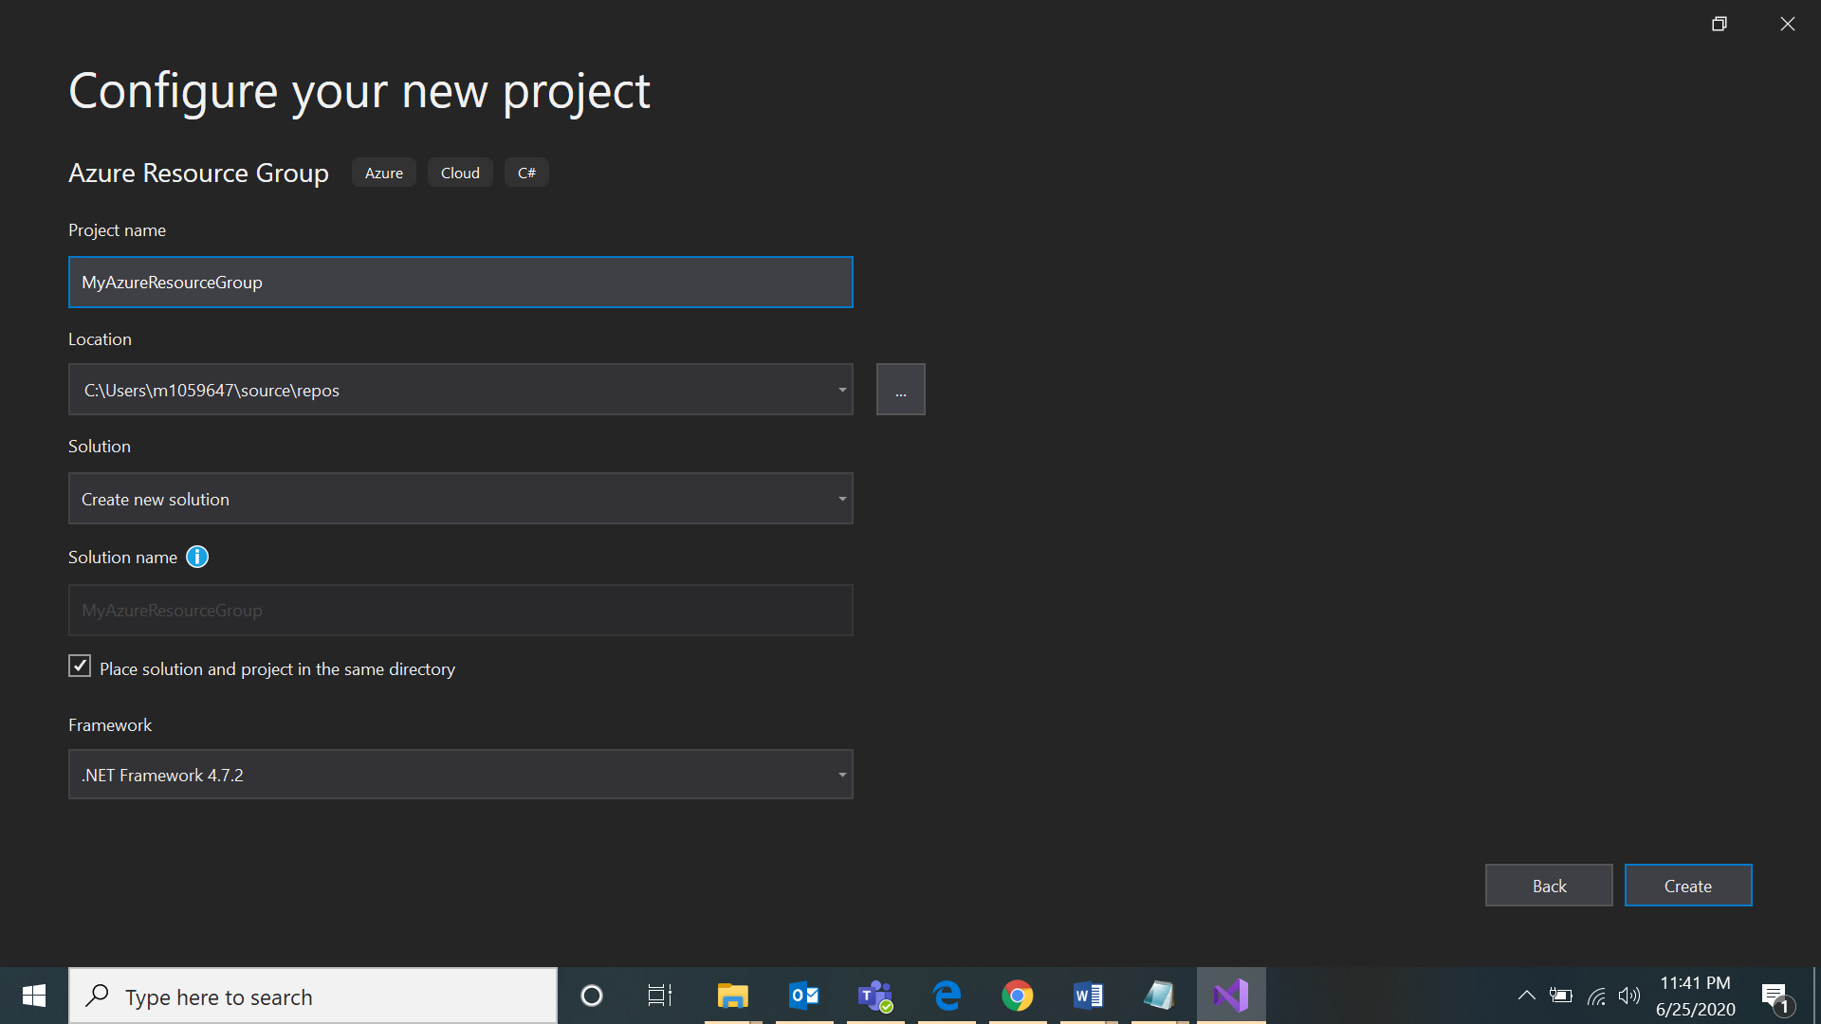

Screenshot 3:

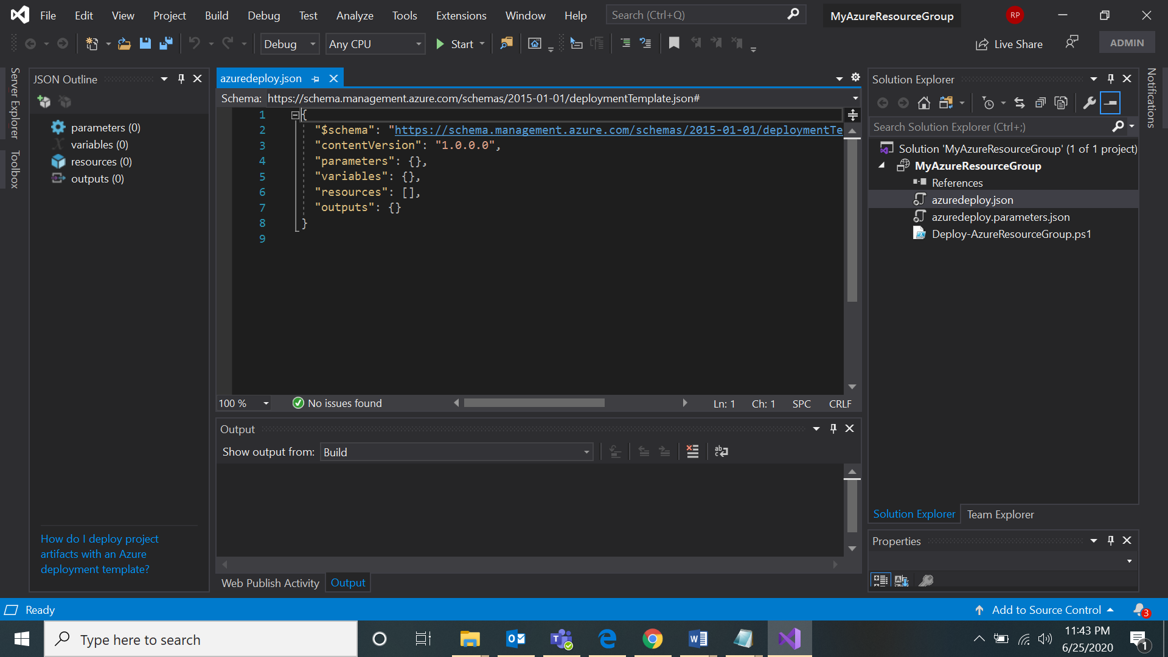

Screenshot 4:

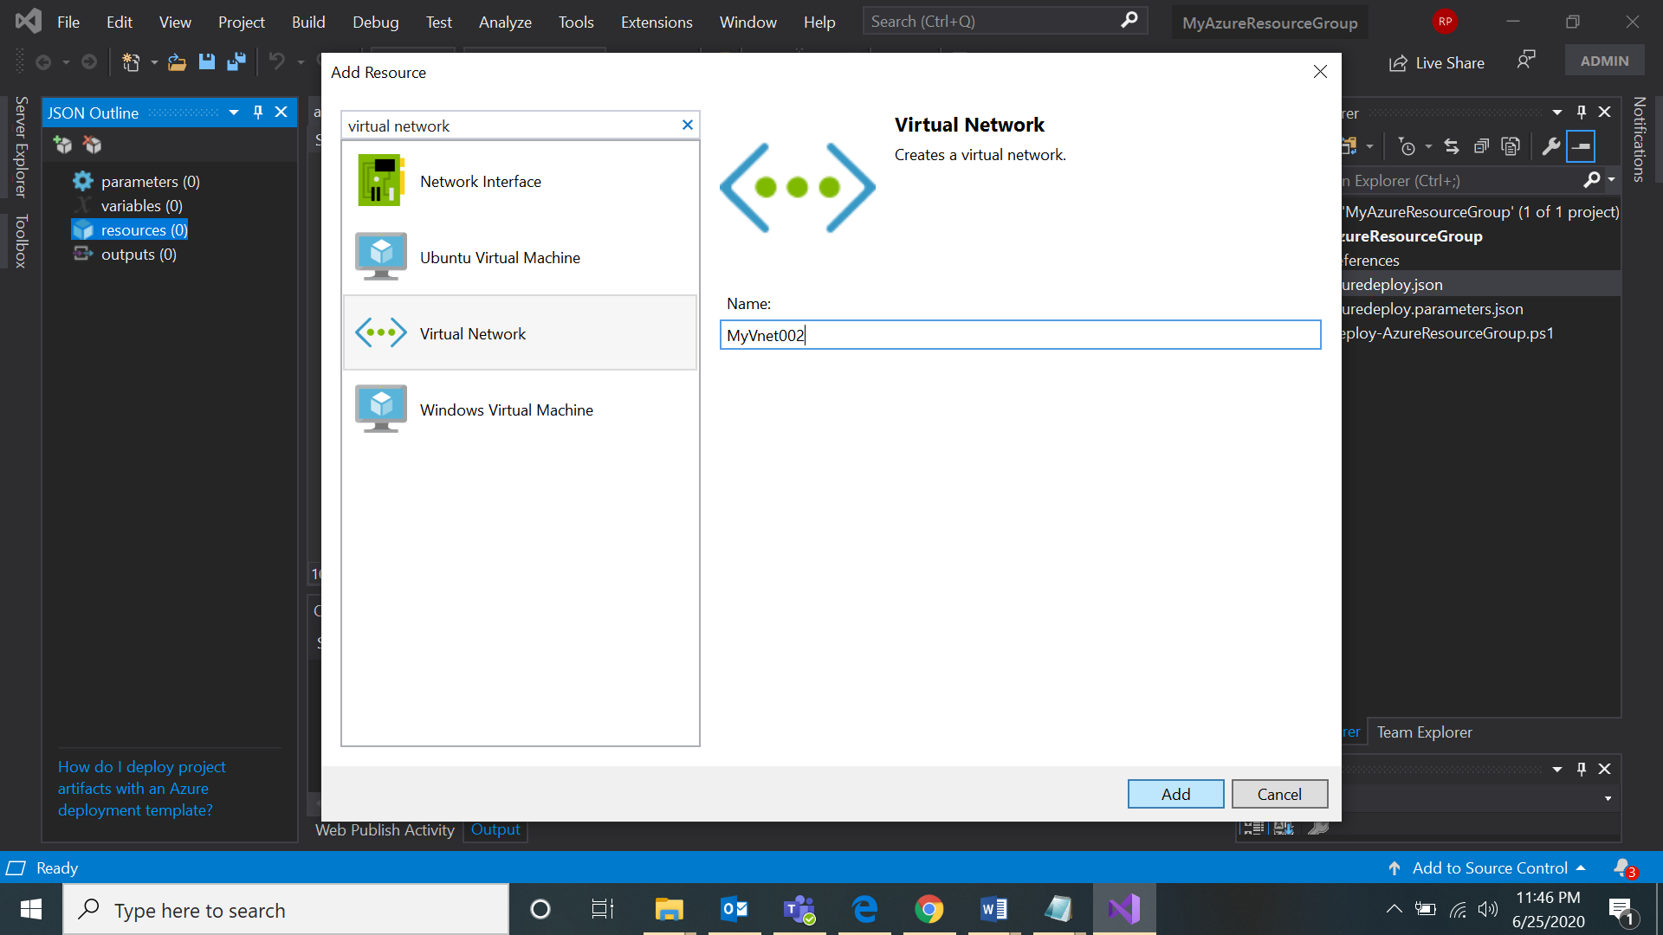

Screenshot 5:

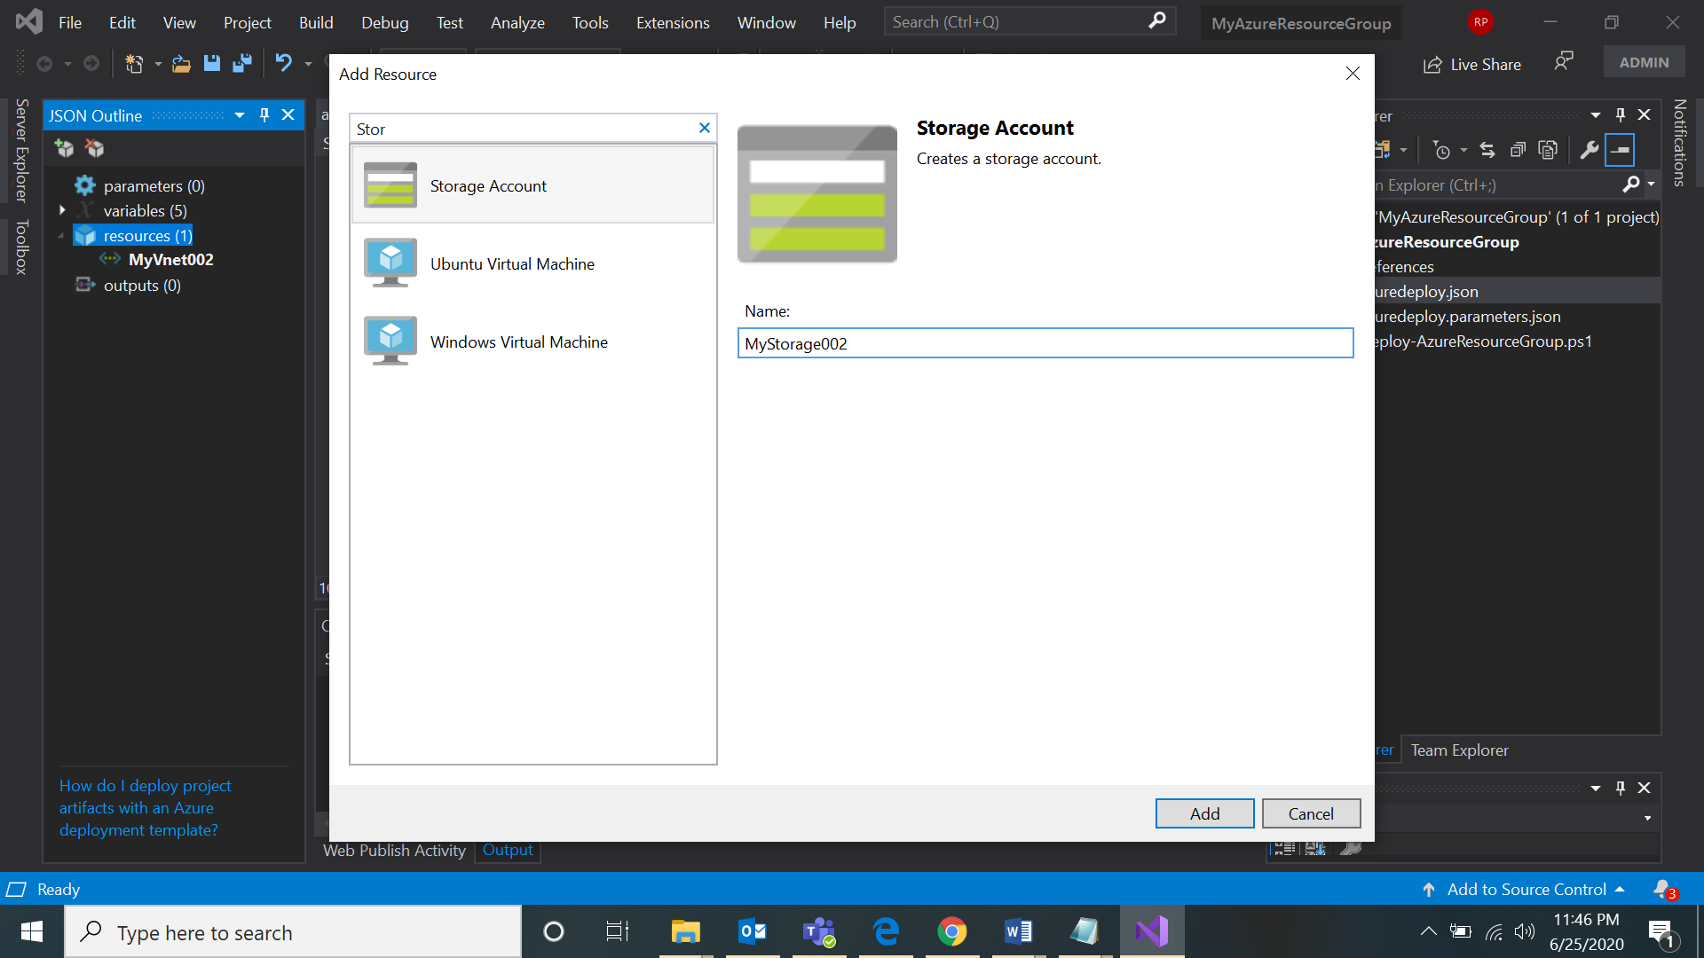

Screenshot 6:

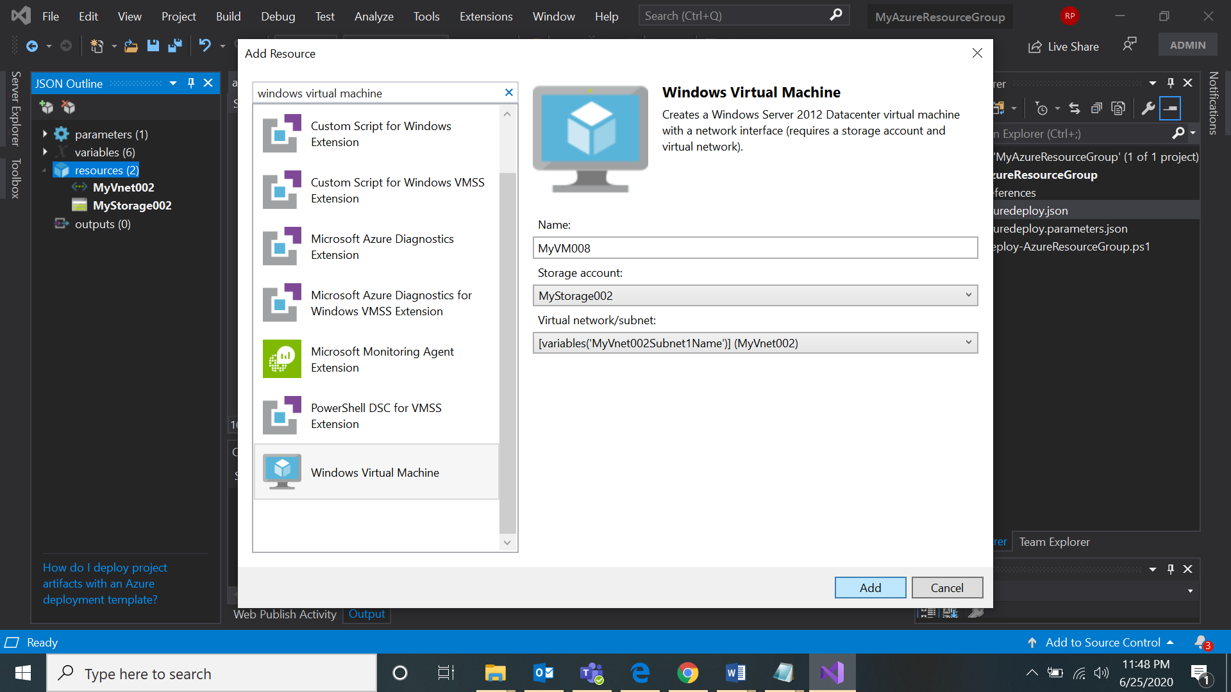

Screenshot 7:

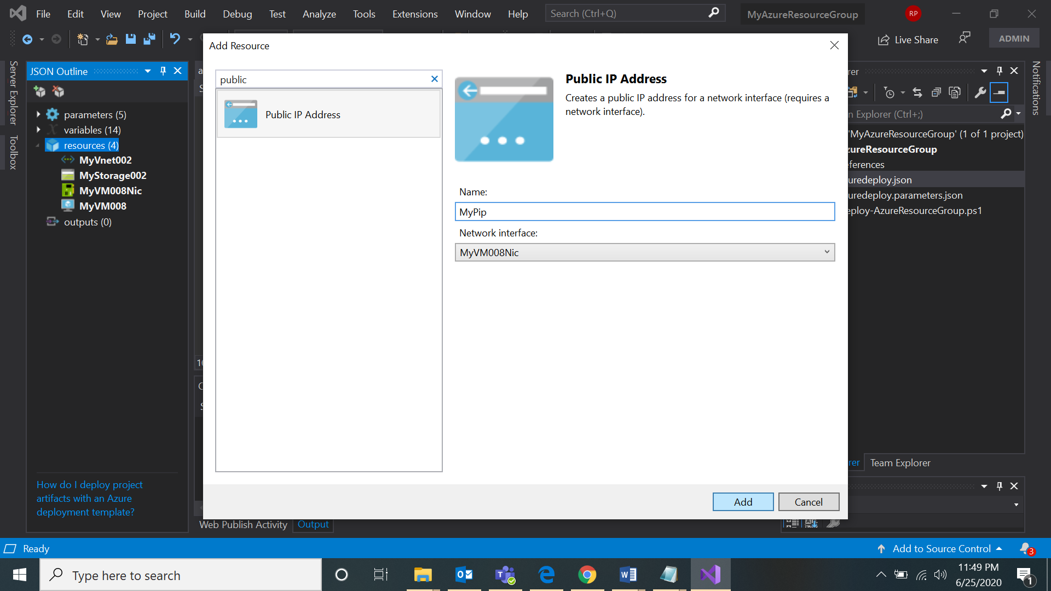

Screenshot 8:

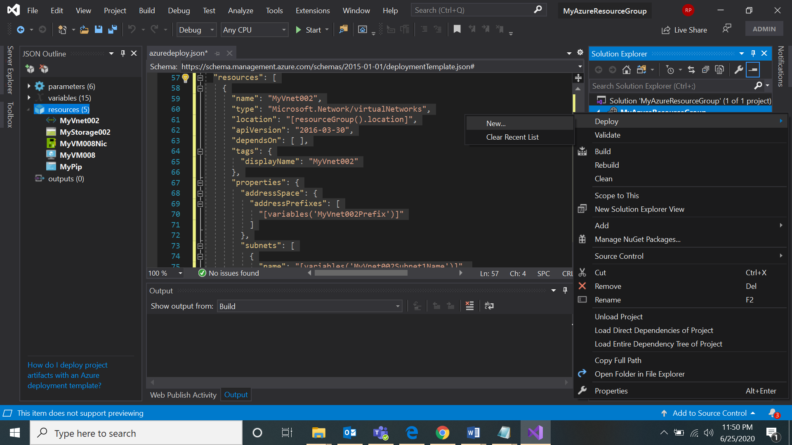

Screenshot 9:

